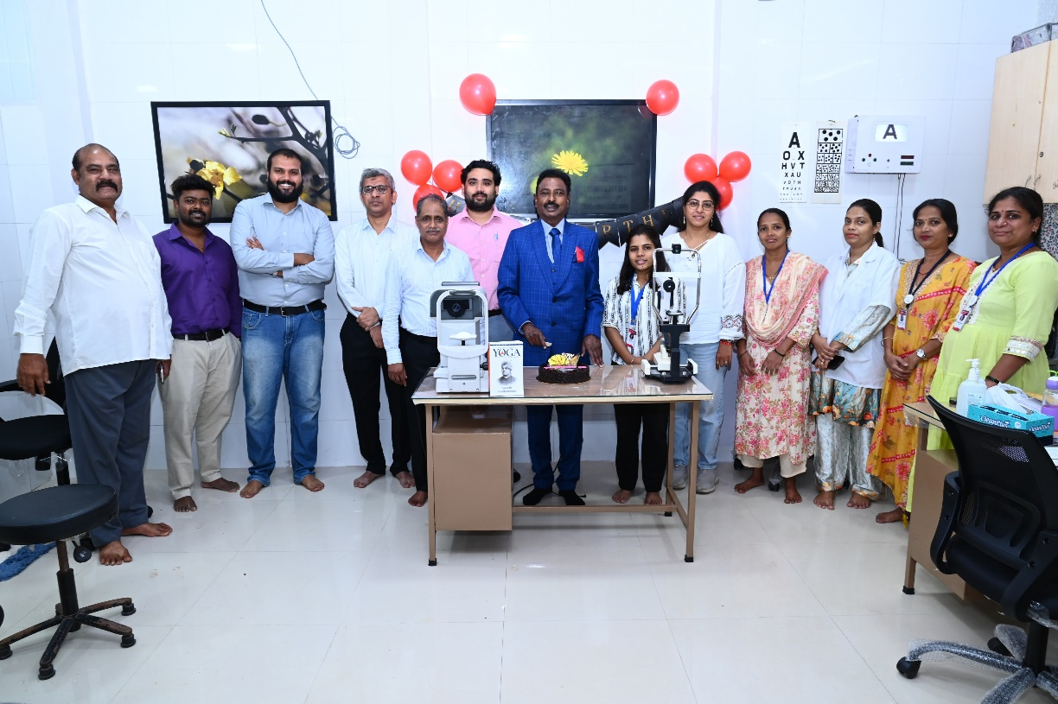
KAMALA SUNDARAM FOUNDATION
NEWSLETTER- JULY TO SEPTEMBER
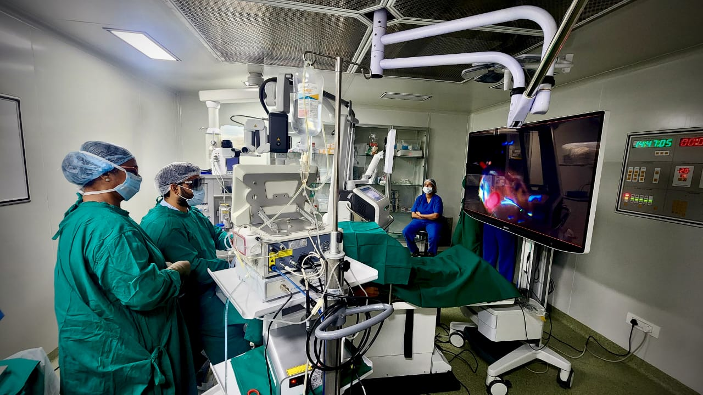
Editorial from Dr. S. Natarajan – 01
Address from Chief Executive Officer – 02
Story So far – 03
Journey of Kamala Sundaram Eye Center – 04
Inauguration of Dharavi Clinic – 06
Camp Activities - 07
Events Organized – 09
Patient testimonials - 11

Table of Contents
KAMALA SUNDARAM FOUNDATION

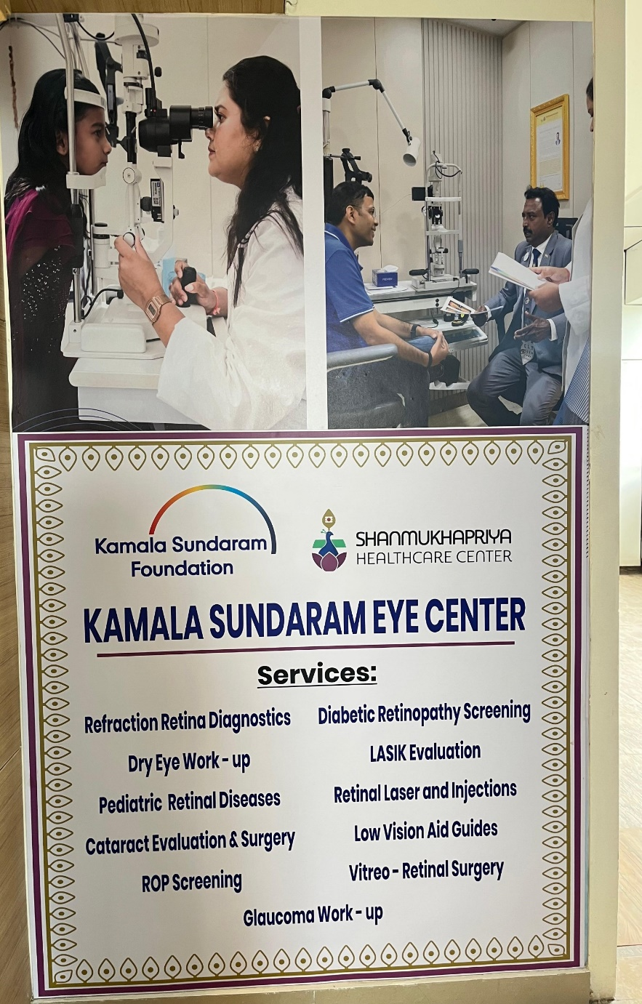
Editorial From Dr. S. Natarajan-
A Legend in his own words

Words from CEO-Mr. Ravichandran

The Story So Far: Kamala Sundaram Foundation

The Kamala Sundaram Foundation (KSF), previously known as the Aditya Jyot Foundation for Twinkling Little Eyes (AJFTLE), is a registered not-for-profit organization established in 2005. The Foundation was born from a powerful inspiration: the desire expressed by Dr. A. P. J. Abdul Kalam (former President of India) during his visit to Aditya Jyot Eye Hospital, where he encouraged an effort to "put a twinkle in the eyes of the visually impaired."
Founding Trustees:
- Padmashree Prof. Dr. S. Natarajan
- Adv. K. G. Menon

Our Vision and Mission
Vision: To foster a society fully aware of basic eye care principles and to be free of preventable eye diseases. Our ultimate goal is to make quality eye care available to every individual through a participatory system.
Mission: To deliver charitable services through a collaborative, community-built system that ensures quality eye care for all. This commitment extends to educational activities focused on promoting eye donation and highlighting preventive aspects of eye health.

Outreach and Impact
The Foundation runs extensive outreach programs across the Rural, Urban slum, and Tribal areas of Maharashtra, striving to provide quality eye care to the underprivileged. KSF manages numerous projects focused on creating awareness, conducting screenings, and delivering comprehensive eye care services to prevent avoidable blindness.
Our activities began humbly in the Dharavi Slums with free eye screening camps. Over the years, our work has dramatically expanded across the Suburbs of Mumbai and neighboring districts in Maharashtra, with the ambitious aim of achieving a Blind-Free Maharashtra.
To date, the Foundation has:
- Conducted over 6,000 camps in Mumbai Slums, Suburban areas, and districts of Maharashtra.
- Screened thousands of school children in BMC schools, providing them with free prescription glasses.
We also take a special and crucial interest in promoting the cause of eye donation as a fundamental way to restore sight and give hope.

Dr. S. Natarajan's Vision: The Kamala Sundaram Eye Center

The Kamala Sundaram Eye Center in Chembur, Mumbai, stands as the realization of Dr. S. Natarajan's long-cherished wish to establish a fully functional, state-of-the-art, charitable ophthalmic institution in the heart of the city.
This long-nurtured idea took shape over a well-furnished 2000 sq ft area, strategically located for accessibility from all parts of Mumbai. The space was graciously provided by the Shanmukhapriya Healthcare Center.
The center was formally inaugurated on July 1, 2025, during a small ceremony attended by Dr. S. Natarajan, the trustees of the Kamala Sundaram Foundation, and the respected trustees of the Shanmukhapriya Healthcare Center.
In just the first three months of operation, the center has treated over 600 patients for various ophthalmic conditions, with a special focus on retinal diseases. Dr. S. Natarajan has entrusted the operational success and clinical excellence of the Kamala Sundaram Eye Center to the highly capable hands of Dr. Avik Dey Sarkar, who has joined the institution as a full-time senior Cataract and Vitreo-Retinal Surgery Consultant.
Dr. Sarkar's strong foundation in academics and his exceptional clinical skills are proving invaluable in easing the diagnosis of complicated retinal pathologies. Furthermore, his extensive experience, having previously operated on thousands of patients, ensures that surgeries performed at the center are smooth, vision-securing, and completed efficiently in minutes.
Under his able leadership, the center has achieved a significant milestone in a short time, having already successfully completed over 100 surgeries in just the first three months.
The facility is equipped with all the latest ophthalmic investigational tools, enabling the quick and accurate diagnosis of complex and intriguing diseases. Furthermore, a fully functional biochemistry lab supports the diagnosis of systemic correlations linked to ophthalmic diseases.
The Kamala Sundaram Eye Center represents a crucial small step toward Dr. Natarajan's larger, inspiring dream of one day making India blind-free.
IMAGES OF THE CENTER

Revitalization of the Kamala Sundaram Vision Center in Dharavi

The Kamala Sundaram Eye Clinic in the heart of the Dharavi slum holds a special place as the first vision center established by the Kamala Sundaram Foundation in 2011. Over the years, it has profoundly impacted the community, serving over 30,000 people in and around Dharavi for various ophthalmic diseases.
Despite facing significant economic challenges following the global COVID-19 pandemic, the clinic admirably kept running against all odds.
We are now delighted to announce the successful revitalization of the Dharavi clinic. Thanks to the invaluable support of Mr. Elton and other well-wishers, the office space has been renovated and equipped with advanced ophthalmic diagnostic tools.
This center now functions as the first vision center under the Kamala Sundaram Eye Center umbrella, serving as a crucial referral center. It's designed to ensure that complex ophthalmic diseases are efficiently diagnosed and managed under the same supportive roof.
The renovated center was inaugurated on September 4th, a date celebrated by the great ophthalmologist's disciples as "World Happy Day," marking Dr. S. Natarajan's birthday. The clinic is now providing all ophthalmic services daily with promptness and efficiency, continuing its vital mission to the community.

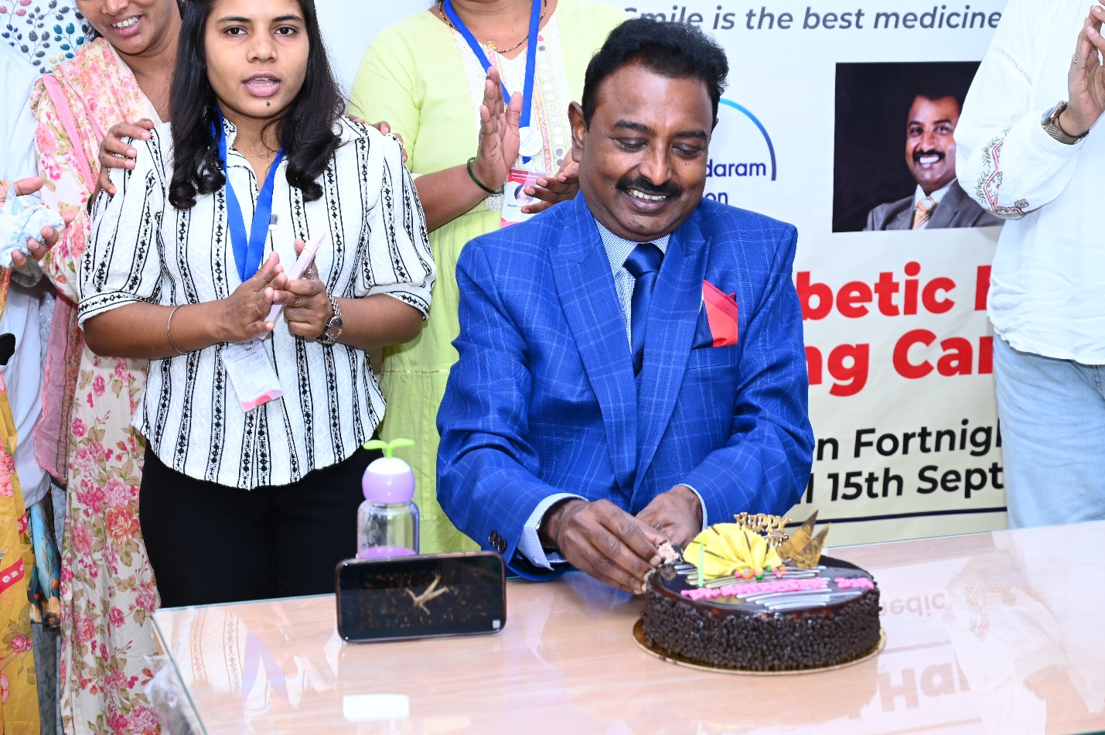
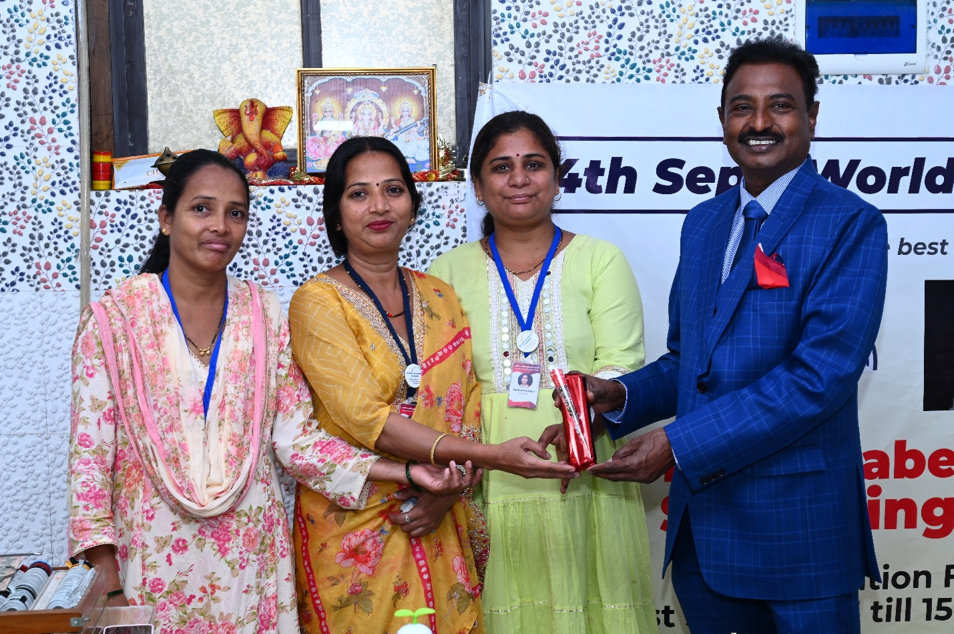

Expanding Our Outreach: Quarterly Camp Activities

Our commitment to accessible and quality eye care has driven a significant increase in outreach efforts over the past quarter. We successfully conducted 31 comprehensive ophthalmic screening camps across various parts of Mumbai, serving over 3,000 people in the last three months alone.
These camp activities were strategically varied to address diverse community needs:
- General Eye Health Screening: Provided basic vision tests and consultations to a large segment of the population.
- Diabetic Retinopathy Screening: Recognizing the rising prevalence of diabetes, several camps were specifically dedicated to screening for this sight-threatening condition, ensuring timely detection and referral.
- School Eye Health Camps: Focused on children, these camps aimed to identify and correct refractive errors and other common pediatric eye problems crucial for a child’s development and education.

New Initiative: Door-to-Door Eye Screening
In a groundbreaking effort to reach the most vulnerable, we have launched a new initiative: Door-to-Door Eye Screening. This project is designed to actively search for "hidden, demonic ophthalmic diseases" within the underprivileged segments of our society.
Our primary and ambitious goal is to search for all possible causes of retinal disease that, if caught and treated in a timely manner, can be cured or managed. This ensures that the poorest members of society, who often cannot afford quality eye care, are given the chance to preserve their sight. By bringing the screening directly to their homes, we are breaking down barriers of access, transportation, and cost, guaranteeing that treatable blindness is prevented within the community.
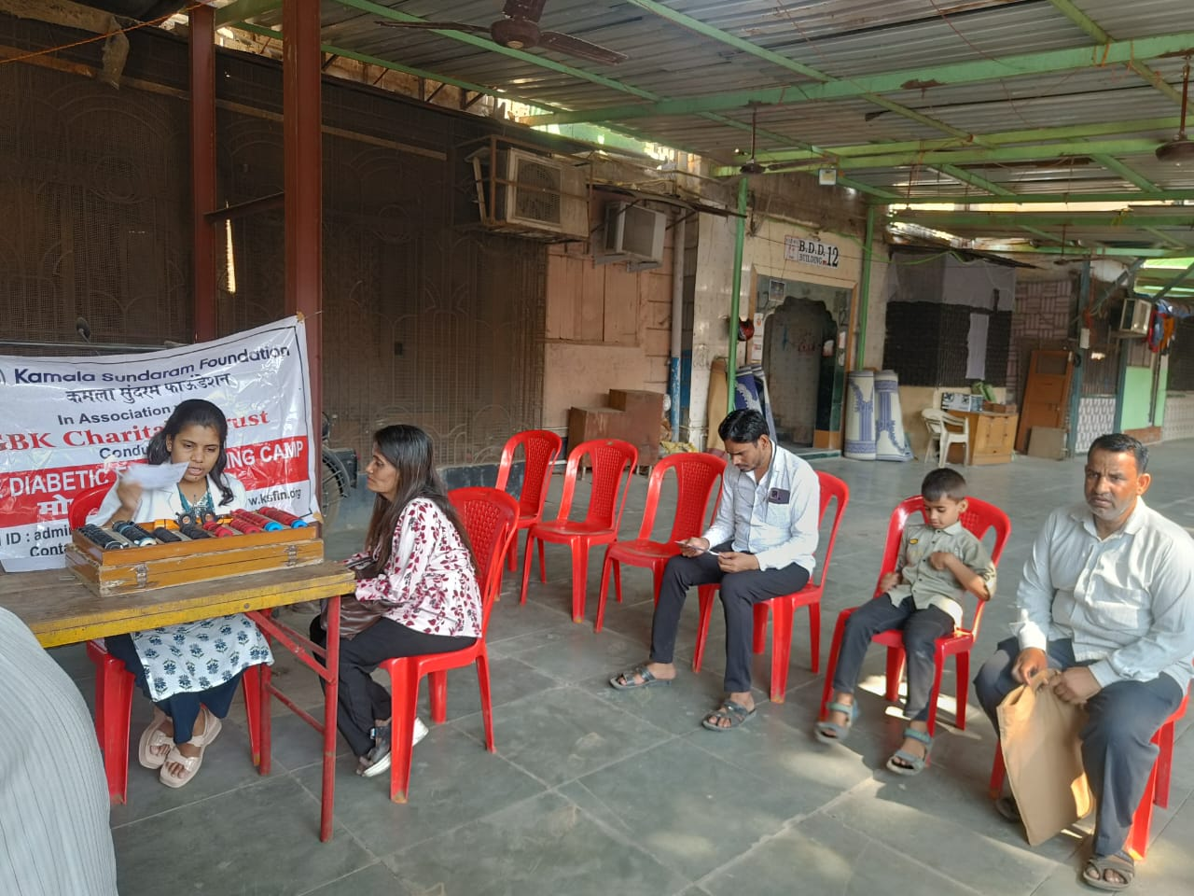

Recent Event: SEELUMA - Innovative Digital & 3D Technology Microsurgery CME

On July 19th, the Kamala Sundaram Eye Center in Chembur hosted a successful Continuing Medical Education (CME) event titled "SEELUMA - INNOVATIVE DIGITAL & 3D TECHNOLOGY MICROSURGERY - A GAME CHANGER IN OPHTHALMOLOGY."
The program was graced by the valuable presence of the respected Dr. Anamika Chawhan, a renowned cognitive scientist and trainer.
The CME served as an important platform where various trained ophthalmologists and retinal surgeons from different reputed ophthalmic institutes delivered mind-bending lectures and showcased brilliant demonstrations of complex surgeries. The event focused on the pivotal role that digital and 3D technology is playing in revolutionizing ophthalmic microsurgery.
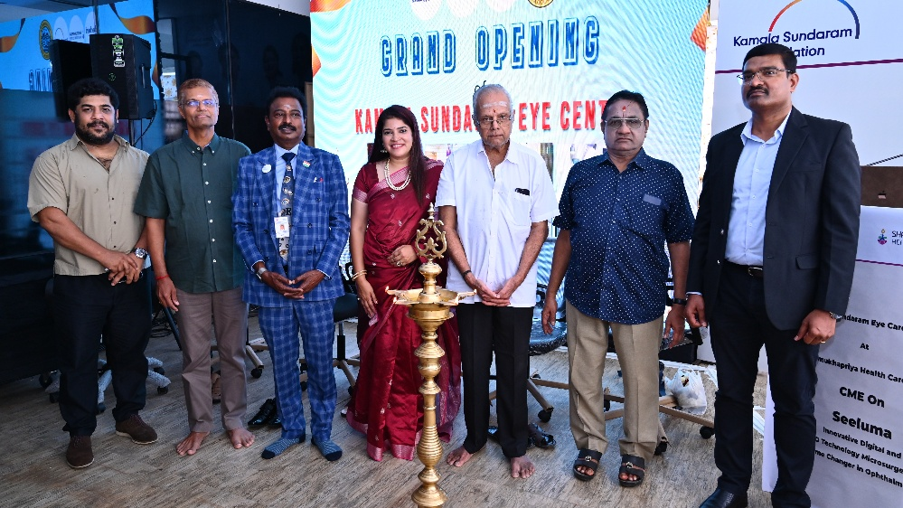

Gratitude to Our Guardians: Special Camp at Chembur Police Station

In a gesture of profound appreciation for the selfless dedication of our law enforcement, the Kamala Sundaram Foundation organized a special camp activity at the Chembur Police Station.
This initiative was driven by a deep desire to extend our gratitude to the brave police personnel who tirelessly deliver their courageous efforts, day and night, throughout the year. Their work is paramount in securing peace and harmony within society and protecting citizens from countless threats.
To offer our small assistance to these heroes without capes, we conducted a holistic eye screening camp on September 23, 2025, right at the police station premises. The camp successfully screened over 50 police personnel and associated staff, ensuring they have access to quality eye care as a token of thanks for the security and protection they provide to all of us.
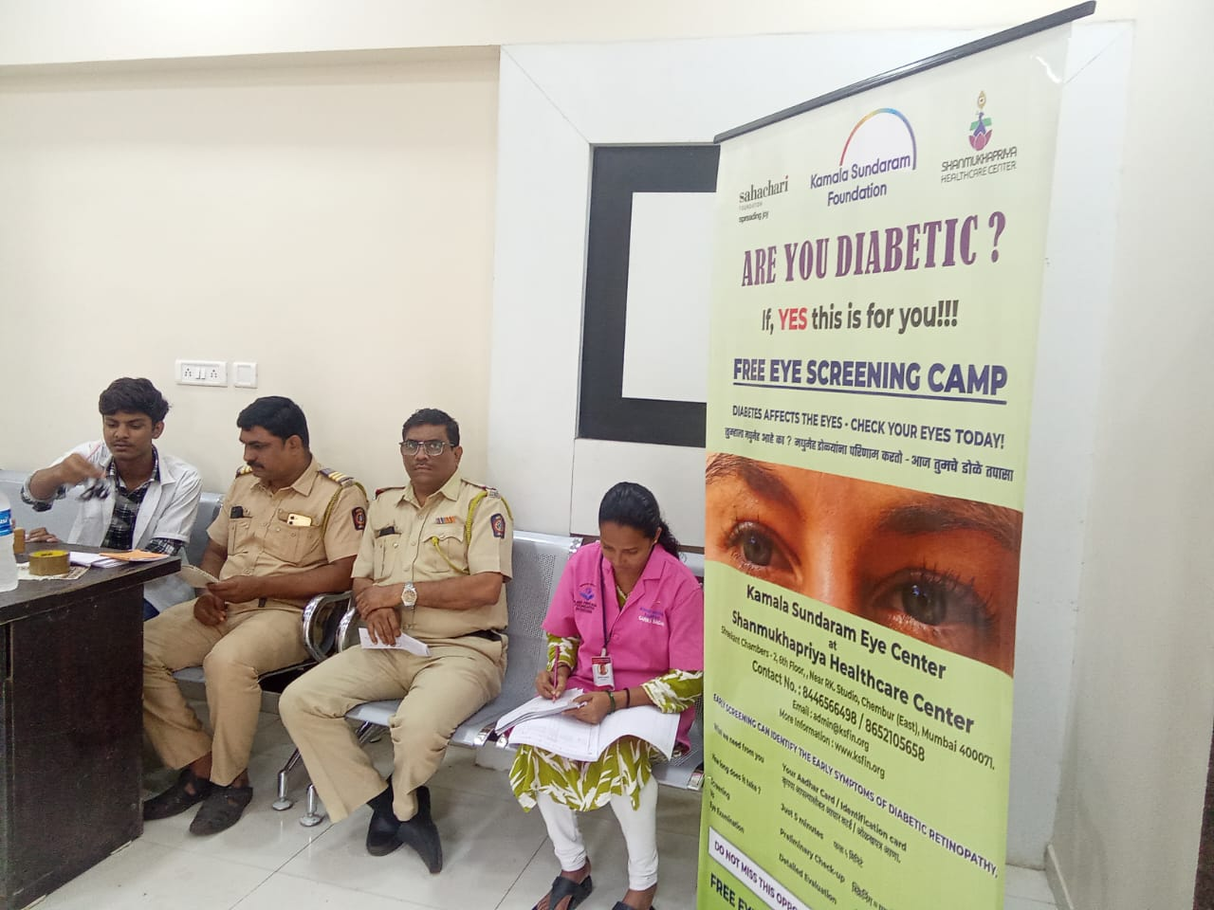

Launching "The Dharavi Project" with Dr. Rupesh Agarwal

The Kamala Sundaram Foundation has initiated a critical new screening program, "The Dharavi Project," launched during the recent visit of Dr. Rupesh Agarwal, a renowned ophthalmologist and research scientist from Singapore.
Dr. Agarwal's visit to our Dharavi clinic was instrumental in launching this vital initiative. The project's motto is to aggressively uncover "the bulk of the iceberg hiding below the tip"—the numerous undiagnosed cases of diabetic retinopathy within the underprivileged population of the Dharavi area. This sight-threatening condition often goes undetected in slum communities, leading to preventable blindness.
During his visit, Dr. Agarwal delivered a deeply motivating speech that helped our social workers and staff understand the larger, life-changing implications behind the project.
Furthermore, his generous efforts were key in acquiring a new piece of state-of-the-art technology: a handheld, AI-powered Remidio™ fundus imaging camera. This cutting-edge device will allow our teams to conduct efficient, high-quality eye screenings during door-to-door visits and community camps within Dharavi.
This focused, systematic screening will explore the exact scenario of diabetic retinopathy in this particular population. The data collected is anticipated to be a pathbreaking analysis for the global ophthalmic community, offering crucial insights into the sociodemographic and potential genetic texture of diabetic retinopathy among slum dwellers.
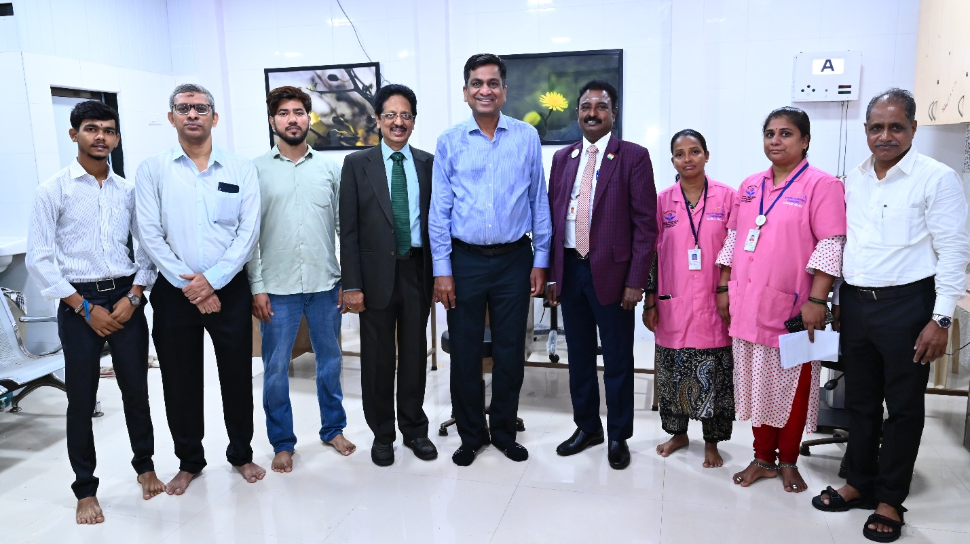
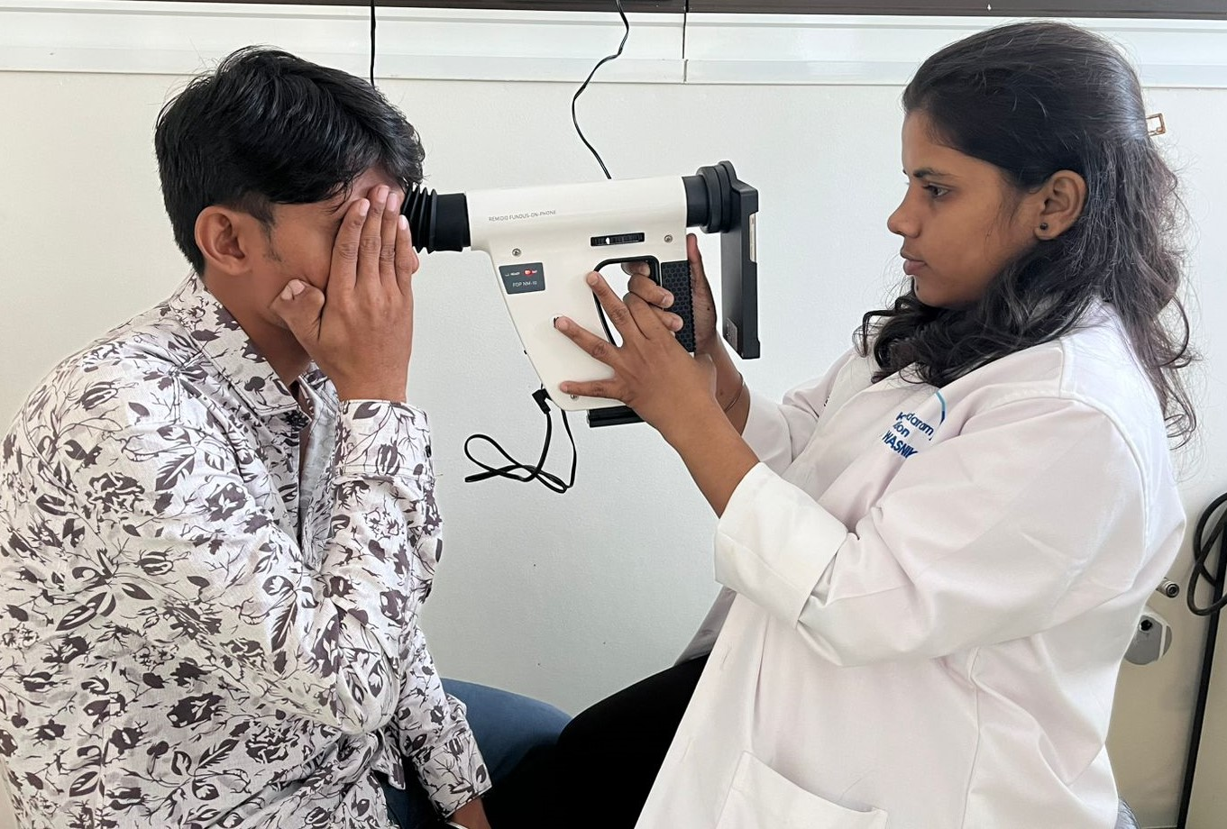

Patient Testimonials: Stories of Hope and Sight Restored

The true measure of our success lies in the impact we have on the lives of our patients. Here are a few heartfelt testimonials from individuals whose sight and quality of life have been transformed by the Kamala Sundaram Foundation:

Master Abhi Mishra (Dharavi Resident)
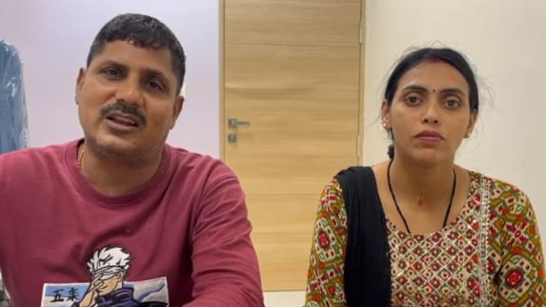
"Our son had a very complicated retinal issue, and we were told that he needed complex surgery. The facilities at the Kamala Sundaram Eye Center are truly world-class, but the care is charitable. I felt completely safe in their state-of-the-art OT. The doctors and nurses treated me with such warmth and professionalism. This foundation is a miracle for Mumbai's underprivileged. They are making a difference where it matters most."

Mrs. Nirmala Yadav (Diabetic Retinopathy Patient)
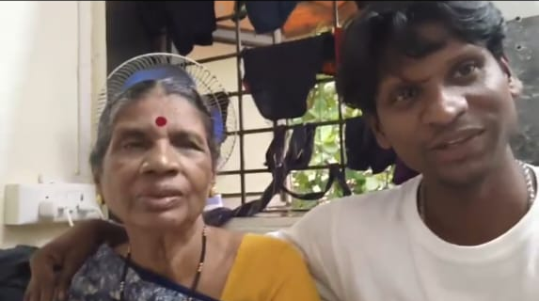
"I have diabetes, but I didn't know it was stealing my sight slowly. When the 'Dharavi Project' team came to my home with their special camera, they found a serious problem in my retina. They immediately referred me to the Chembur center. The doctors were very kind and explained everything. I was given timely laser treatment and my vision is now stable. If they hadn't come to my door, I would have been blind today. I am so thankful for their effort to help poor people like us."

Mrs. Sumitra Shedge (Chembur Center Surgical Patient)
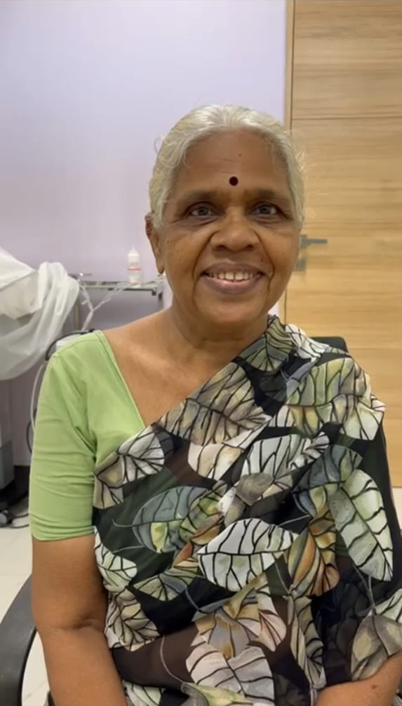
"For years, I was struggling to see clearly. It was getting harder to do my daily work. I thought I would have to give up my job. When the Kamala Sundaram team came to our area in Dharavi, they diagnosed my cataract right away. I was taken to the new Eye Center in Chembur and the surgery was done completely free of cost. Now I can see the world clearly again. They gave me back my future. God bless Dr. Natarajan and the whole team."

